Military Institute of Science and Technology
Department of Computer Science and Engineering
Course Title: Data and Tele-Communication Sessional
Course Code: CSE-318, Cr. Hr: 1.50
Level-3, Term-2

Experiment No: 02
Name of the Experiment: AM Demodulation by Diode detector

1. Objectives:

To understand the theory of amplitude demodulation.
To design and implement the diode detection amplitude demodulator.
To design and implement the product detection amplitude demodulator.
To understand the measurement and adjustment of AM demodulator.

- Theory:

From chapter 3, we know that amplitude modulation signal utilize the amplitude of audio signal to modulate high frequency carrier signal. Therefore, when we receive the amplitude modulation signal, we need to restore the audio signal. Fig 4-1 is the theory diagram of amplitude modulation. Normally detector can be classified as synchronous detector and asynchronous detector. We will discuss these two types of detectors in this experiment.

Diode detector for Amplitude Demodulation:

Since amplitude modulation signal utilize the amplitude of audio signal to modulate high frequency carrier signal, which means the variation of carrier signal amplitude is followed by the change of audio signal amplitude. Hence the objective of amplitude demodulator is to take out the variation envelop detection from modulation AM signal. Fig 4-2 is the block diagram of diode detector. This circuit is typical asynchronous detector. It rectifies the modulated AM signal and obtains a positive half wave signal. After that the signal will pass through a low pass filter and obtain an envelop detection. The n get rid of the DC signal, the aidio will be recovered. If the input signal of the diode detector is the over modulated AM signal, as shown in fig 4-2. The n we are unable to recover the distorted signal to the audio signal by the diode detector. As for the over modulated AM signal, we need to use the product detector to demodulated this kind of signal, which will be discussed in next section.

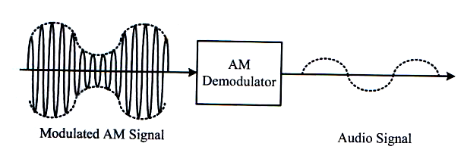

Figure 4-1 Theory diagram of amplitude demodulator.

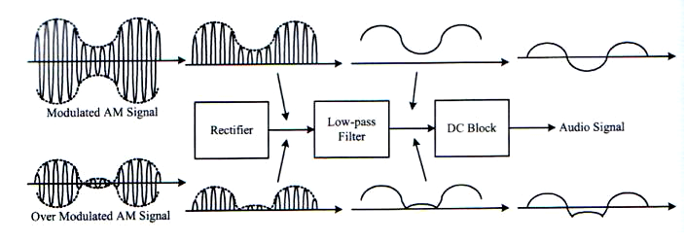

Figure 4-2 Block diagram of diode detector.

Figure 4-3 Circuit diagram of diode detector.

Fig 4-3 is the circuit diagram of diode detector, in which resistors R1, R2, R3, R4, U1 and U2 form two groups of inverting amplifiers to amplify the input signal, the amplified rate is 10 times of the original signal; Diode D1 is the rectifier diode which can make the amplitude modulation signal become a positive half wave signal. Capacitor C1, C2 and Resistor R5, R6 comprise a low-pass filter to remove the envelop detection signal of audio signal which includes the DC level; then finally the objective of C3 is to block the DC level and we can obtain a pure audio signal at output port.

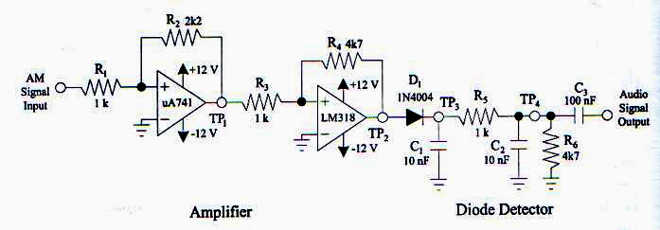
3. Equipment Needed:

  - ETEK ACS 3000-02 module.
  - Oscilloscope
  - Signal source (Function generator)

4. Procedure:

- Refer to the circuit diagram in figure 3-7 or figure ACS3-2 on ETEK ACS 3000-02 module. Let J1 be short circuit and J2 be open circuit to produce the modulated AM signal as the signal source in this experiment.
- At audio signal input port (Audio I/P), input 600 mV amplitude, 3 kHz sine wave frequency; at carrier signal input port (carrier I/P), input 300 mV amplitude, 300 kHz sine wave frequency.
- Adjust VR₁ so that the modulation index of the AM signal is maximum adjust VR₂ so that the signal at AM O/P1 is 250 mV_{p-p.}
- Connect the output signal of the AM modulator (AM O/P1) to the input port (AM I/P) of diode detector in figure 4-3 or figure ACS4-1 on ETEK ACS-3000-02 module.
- By using oscilloscope and switching to DC channel, observe on the first stage (TP1) and second stage (TP2) amplified signal waveforms. Then record the measured results in table 4-1.
- By using oscilloscope, observe on the output signal waveforms of the rectifier (TP3). Then record the measured results in table 4-1.
- By using oscilloscope, observe on the output signal waveforms of the low-pass filter (TP4) and the demodulated AM out[put port (Audio O/P). Then record the measured results in table 4-1.
- According to the input signals in table 4-1, repeat step 4 to step 7 and record the measured results in table 4-1.
- According to the input signals in table 4-2, repeat step 3 to 7 and record the measured results in table 4-2

Table 4-1 Observe on the variation of amplitude modulation by changing the amplitude of audio signal.(f_{m}=2kHz, f_{c}=300kHz,V_{c}=300mV)

Output Signal Ports | Audio Signal Amplitudes
Output Signal Ports | 600 mV | 300mV
AM I/P
TP1
TP2
TP3
TP4
Audio O/P

Table 4-2 Observe on the variation of amplitude modulation by changing the frequency of audio signal.(V_{m}=600mV, f_{c}=300kHz,V_{c}=300mV)

Output Signal Ports | Audio Signal Frequencies
Output Signal Ports | 3kHz | 6 kHz
AM I/P
TP1
TP2
TP3
TP4
Audio O/P

Problem discussion

- By using diagram, explain the reasons why the diode detector is unable to recover the over modulated AM signal to the original audio signal.
- Refer to fig 4-3, explain the results if we connect the output of AM modulator to the diode detector without two stage amplifier, what will the results be.
- Refer to fig 4-3, describe the function of low- pass filter in diode detector. And also explain what kinds of components comprise the low-pass filter.
- Refer to figure 4-5, explain the results if the carrier signal and modulated AM signal are asynchronous.
- Refer to figure 4-5, explain the objectives of VR₁ and VR₂.
- Refer to figure 4-5, explain the objectives of C_{7,} C₉ and C₈.
- Refer to figure 4-5, explain the objectives of VR₃ and R₅.

